FAKE API – JSONPlaceholder

Website Link : https://jsonplaceholder.typicode.com/

About :
- JSONPlaceholder provides Free fake API for testing and prototyping.
- It provides a bunch of APIs that have dummy data to work on.

Resources:
- JSONPlaceholder comes with a set of 6 common resources:
- We can use any of the API for dummy data or testing.

Serial No. | APIs | Data
1 | /posts | 100 posts
2 | /comments | 500 comments
3 | /albums | 100 albums
4 | /photos | 5000 photos
5 | /todos | 200 todos
6 | /users | 10 users

Note: resources/apis have relations. For example: posts have many comments, albums have many photos, ... see guide for the full list.

Routes
- All HTTP methods are supported. You can use http or https for your requests.
- In below table we are taking /posts & /comments api to demonstrate the routes, for other apis it remains the same.

Serial No. | Method | Endpoint | Data
1 | GET | /posts | Fetch all the posts available
2 | GET | /posts/1 | Only fetch the post for the given post id in the endpoint.
3 | GET | /posts/1/comments | Fetch all the comments of the post with the given post id in the endpoint.
4 | GET | /comments?postId=1 | Fetch all the comments of the post with the given post id in the endpoint
5 | POST | /posts | Create a new post with the post data passed in the body of the POST request.
6 | PUT | /posts/1 | Modify the post's details of the given post id
8 | DELETE | /posts/1 | Delete the post with the given post id

Note: see guide for usage examples.

USAGE :
- Listing all resources

Code :
fetch('https://jsonplaceholder.typicode.com/posts')
.then((response) => response.json())
.then((json) => console.log(json));

Result :
[
{ id: 1, title: '...' /* ... */ },
{ id: 2, title: '...' /* ... */ },
{ id: 3, title: '...' /* ... */ },
/* ... */
{ id: 100, title: '...' /* ... */ },
];

- Getting a resource
Code :
fetch('https://jsonplaceholder.typicode.com/posts/1')
.then((response) => response.json())
.then((json) => console.log(json));
Result :
{
id: 1,
title: '...',
body: '...',
userId: 1
}

PROJECT – Listing App

About :
It's a simple listing app, which will be using the apis to get the fake/dummy data from the JSONPlaceholder and presenting the data on our app. It has been built on ReactJS with different libraries like axios for http request handling, react-paginate to add pagination and bootstrap for styling.

Create Project
- Create a new react project via CLI i.e., create react app or create vite, command – npx create-react-app project_name, npm create vite project_name.
- This project has been built via create vite.
- Perform code cleanup, deletes unnecessary files.
- Install the following libraries – react-paginate, react-bootstrap, bootstrap & axios.
- Create a Folder components in src in which we will create the components.

Folder Structure:
Project Folder
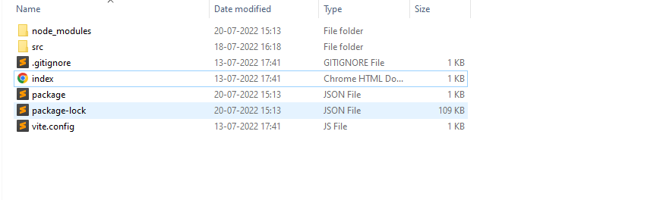
src Folder
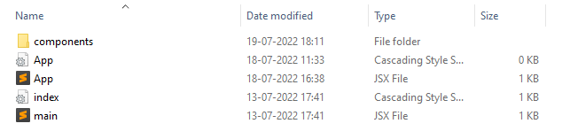
components Folder
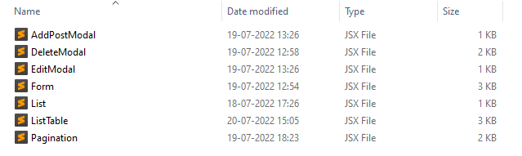

Description
In our component folder we have 7 components :
- AddPostModal – A simple modal which will allow user to add a new record.
- EditModal – A simple modal which will allow user to edit an existing record.
- DeleteModal – A simple modal which will confirm user's action to delete a record.
- Form – A simple html form embeded inside the modal, which will display the fields of the records along with the appropriate label.
- ListTable – A html table to display the records on the screen.It
consists of List components.
- List – This component generates table row for the data received from the api.
- Pagination – This component is handling the pagination of the app and the number of List component to show on the ListTable.

Other Important Files :
- Main.jsx – This file contains the ReactDom component which takes App.jsx as it's child component. Whatever component is passed as a child component to ReactDom, will be display on the screen.
- App.jsx – App.jsx is the main component of a react app. It's the only component which is read by react-dom and imported inside the main.jsx file to render it on the screen. Components should be use inside this file.
- Package.json – This file contains the meta data and all the dependencies/libraries used in the react-app.
- Vite.config – It contains configuration of vite tool.

App.jsx
In App.jsx we have Container component from react bootstrap with some classes applied on it and inside that we have our ListTable component which is generating the
data List on screen.

import './App.css'
import ListTable from './components/ListTable'
import { Container } from 'react-bootstrap'
import 'bootstrap/dist/css/bootstrap.min.css';

function App() {
return (
<div className="App">
<Container className='mt-5 col-12'>
<ListTable/>
</Container>
</div>
)}

export default App

ListTable Component

import { useEffect, useState } from 'react';
import Table from 'react-bootstrap/Table';
import List from './List';
import axios from 'axios'
import EditModal from './EditModal';
import DeleteModal from './DeleteModal';
import { Button, Container } from 'react-bootstrap'
import AddPostModal from './AddPostModal'
import Pagination from './Pagination';

const ListTable = ()=> {

//store the data from the api and generate an array of List component
const [AllPosts,setAllPosts] = useState([]);
//stores the array of List component generated by getLists function
const [posts,setPosts] = useState([]);
//stores & display the array of List component according to the items per page range and updates on pagination
const [lists,setLists] = useState(null)
//stores the post which needs to be edited or deleted
const [changePost,setChangePost] = useState(null);
const [showEditModal,setShowEditModal] = useState(false);
const [showDeleteModal,setShowDeleteModal] = useState(false);
const [showAddPostModal,setShowAddPostModal] = useState(false);

const setPostsPerPage = (items)=>{
setPosts(items)
}

const showEditModalHandler = (post)=>{
setShowEditModal(true);
//save post which needs to be change or edit
setChangePost(post)
}

const showDeleteModalHandler = (post)=>{
setShowDeleteModal(true);
//save post , needs to be deleted
setChangePost(post)
}

//function that returns an array of List component with api's data
const getLists = ()=>{
return AllPosts&&AllPosts.map((post,id)=>(
<List showEditModal={()=>showEditModalHandler(post)} showDeleteModal={()=>showDeleteModalHandler(post)} key={id} post={post} serialNo={id}/>
))
}

useEffect(()=>{
setLists(getLists())
},[AllPosts])

useEffect(()=>{
//call the api whenever modal is closed to get the new modified/deleted data
if( !showEditModal && !showDeleteModal && !showAddPostModal){
axios.get('https://jsonplaceholder.typicode.com/posts')
.then(res=>setAllPosts(res.data))
}
},[])

return (
<>
<Container className='d-flex my-5 align-items-center justify-content-center'>
<Button onClick={()=>setShowAddPostModal(true)} variant='outline-dark'>Add Post</Button>
</Container>
<Table striped bordered hover responsive>
<thead>
<tr>
<th className='text-center'>UserID</th>
<th className='text-center'>PostID</th>
<th className='text-center'>Title</th>
<th className='text-center'>Body</th>
<th className='text-center'>Controls</th>
</tr>
</thead>
<tbody>
{
posts
}
</tbody>
</Table>
<EditModal post={changePost} show={showEditModal} onHide={()=>setShowEditModal(false)}/>
<DeleteModal post={changePost} show={showDeleteModal} onHide={()=>setShowDeleteModal(false)}/>
<AddPostModal postid={parseInt(AllPosts[0]?.id)+1} show={showAddPostModal} onHide={()=>setShowAddPostModal(false)}/>
<Pagination items={lists} setPaginationItems={setPostsPerPage} itemsPerPage={5}/>
</>
);
}

export default ListTable;

List Component

import { Button } from 'react-bootstrap'

const List = ({post, showEditModal, showDeleteModal})=>{

return(
<tr>
<td className='text-center'>{post.userId}</td>
<td className='text-center'>{post.id}</td>
<td className='text-center text-wrap w-25'>{post.title}</td>
<td className='text-center text-wrap w-25'>{post.body}</td>
<td className='text-center align-middle'>
<Button className='w-25 m-1' onClick={showEditModal} variant='outline-primary'>Edit</Button>
<Button className='w-25 m-2' onClick={showDeleteModal} variant='outline-danger'>Delete</Button>
</td>
</tr>
)
}

export default List;

EditModal Component

import {Modal} from 'react-bootstrap';
import PostForm from './Form';

const EditModal = (props)=> {

return (
<Modal {...props} aria-labelledby="contained-modal-title-vcenter" centered>
<Modal.Header className='bg-primary text-white' closeButton closeVariant='white'>
<Modal.Title id="contained-modal-title-vcenter">
Edit Post
</Modal.Title>
</Modal.Header>
<Modal.Body>
<PostForm editModal post={props.post} onHide={props.onHide}/>
</Modal.Body>
</Modal>
);
}

export default EditModal;

DeleteModal Component

import {Modal, Button} from 'react-bootstrap';
import axios from 'axios'
import PostForm from './Form';

const DeleteModal = (props)=> {
const deleteListHandler = ()=>{
axios.delete(`https://jsonplaceholder.typicode.com/posts/${props.post.id}`)
.then(res=>props.onHide())
}

return (
<Modal {...props} centered>
<Modal.Header className='bg-danger text-white' closeButton closeVariant='white'>
<Modal.Title>Delete Record</Modal.Title>
</Modal.Header>
<Modal.Body>
<h6>Are you sure, you want to delete this record ?</h6>
</Modal.Body>
<Modal.Footer className='d-flex align-items-center justify-content-evenly' >
<Button className='w-25' variant="primary" onClick={deleteListHandler}>Yes
</Button>
<Button className='w-25' variant="secondary" onClick={props.onHide}>No
</Button>
</Modal.Footer>
</Modal>
);
}
export default DeleteModal;

AddPostModal Component

import { Modal} from 'react-bootstrap';
import PostForm from './Form';

const AddPostModal = (props)=>{

return(
<Modal {...props} centered>
<Modal.Header className='bg-dark text-white' closeButton closeVariant='white'>
<Modal.Title>Add Record</Modal.Title>
</Modal.Header>
<Modal.Body>
<h6>Please fill the below details :</h6>
<PostForm postid={props.postid} onHide={props.onHide}/>
</Modal.Body>
</Modal>
)
}

export default AddPostModal;

Form Component

import { Form, Row, Col, Modal, Button } from 'react-bootstrap';
import { useState, useEffect } from 'react';
import axios from 'axios';

const PostForm = (props)=>{

const [post,setPost] =useState({
userId : props.editModal?(props.post?.userId):'1',
id : props.editModal?props.post?.id:props.postid,
body : props.editModal?props.post?.body:'',
title : props.editModal?props.post?.title:''
})

const changeInputHandler = (e,field)=>{
switch(field){
case 'body' : setPost({...post, body : e.target.value});break;
case 'title' : setPost({...post, title : e.target.value});break;
}
}

const submitButtonHandler = (event)=>{
event.preventDefault();
//edit operation
if(props.editModal){
axios.put(`https://jsonplaceholder.typicode.com/posts/${props.post.userId}`,post)
.then(res=>props.onHide())
}
//addPost operation
else{
axios.post('https://jsonplaceholder.typicode.com/posts',post)
.then(res=>props.onHide())
}

}

return(
<Form className={!props.editModal&&'mt-3 border p-2'}>
<Form.Group as={Row} className='mb-2'>
<Form.Label column sm='2'>
<h6>Body</h6>
</Form.Label>
<Col sm='10' md='20'>
<Form.Control className='w-100' value={post.body} onChange={(event)=>changeInputHandler(event,'body')}></Form.Control>
</Col>
</Form.Group>
<Form.Group as={Row} className='mb-1'>
<Form.Label column sm='2'>
<h6>Title</h6>
</Form.Label>
<Col sm='10' md='20'>
<Form.Control className='w-100' value={post.title} onChange={(event)=>changeInputHandler(event,'title')}></Form.Control>
</Col>
</Form.Group>
<Form.Group className='text-end mt-3'>
<Button className='mx-auto' variant='primary' type='submit' onClick={submitButtonHandler}>Submit</Button>
</Form.Group>
</Form>
)}
export default PostForm;

Pagination Component

import ReactPaginate from 'react-paginate';
import { useEffect, useState } from 'react';
import { Stack } from 'react-bootstrap';

const PaginatedItems = ({ items, setPaginationItems, itemsPerPage })=>{
// We start with an empty list of items.

const [pageCount, setPageCount] = useState(0);
// Here we use item offsets; we could also use page offsets
// following the API or data you're working with.
const [itemOffset, setItemOffset] = useState(0);
const endOffset = itemOffset + itemsPerPage;

useEffect(() => {
// Fetch items from another resources.
setPaginationItems(items?.slice(itemOffset, endOffset));
setPageCount(Math.ceil(items?.length / itemsPerPage));
}, [itemOffset, itemsPerPage,items]);

// Invoke when user click to request another page.
const handlePageClick = (event) => {
const newOffset = (event.selected * itemsPerPage) % items?.length;
setItemOffset(newOffset);
};

return (
<>
<Stack direction='horizontal'>
<h6 className='mx-auto'>{`Showing ${itemOffset+1}-${endOffset} of ${items?.length} records`}</h6>
</Stack>
<ReactPaginate
className='nav justify-content-center gap-2 mt-2 my-5'
pageClassName='d-flex align-items-center'
nextClassName='nav-item btn btn-primary p-0 ms-3'
nextLinkClassName='nav-link text-white'
activeLinkClassName='btn bg-dark text-white'
pageLinkClassName=' h-75 btn btn-sm border-1 border-dark'
breakLabel="..."
nextLabel="next"
onPageChange={handlePageClick}
pageRangeDisplayed={5}
pageCount={pageCount}
previousLinkClassName='nav-link text-white'
previousClassName='nav-item btn btn-dark p-0 me-3'
previousLabel="prev"
renderOnZeroPageCount={null}
/>
</>
);
}

export default PaginatedItems;

Working
Home Screen
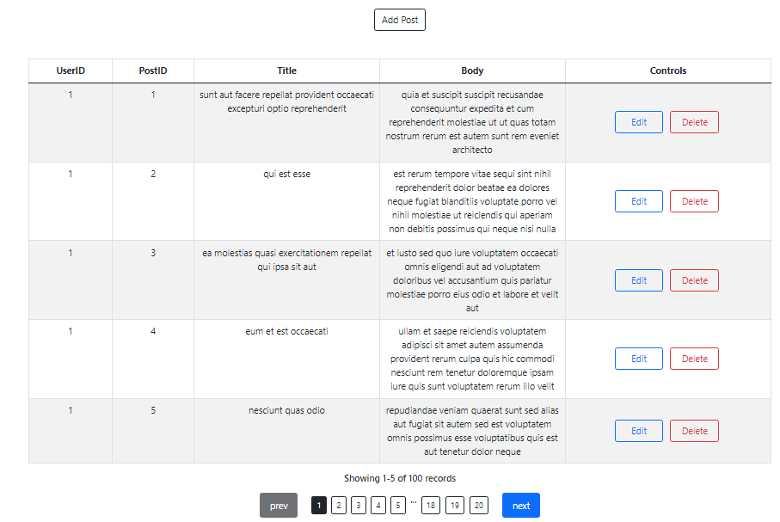

Add Post button
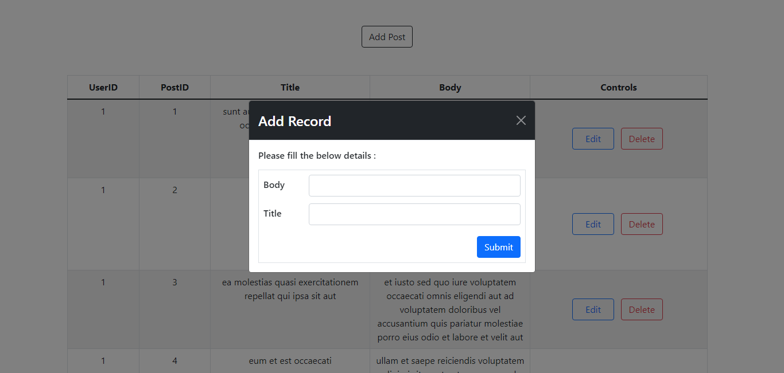
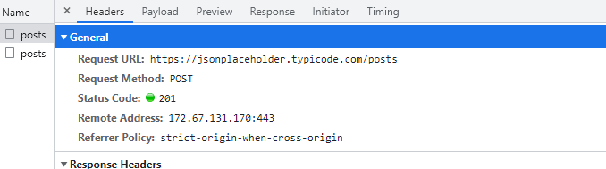
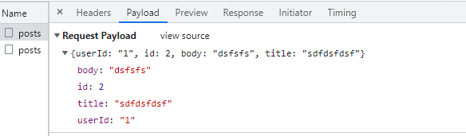

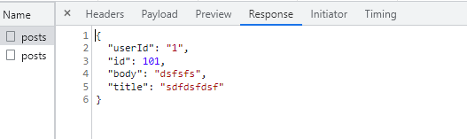

Edit Button
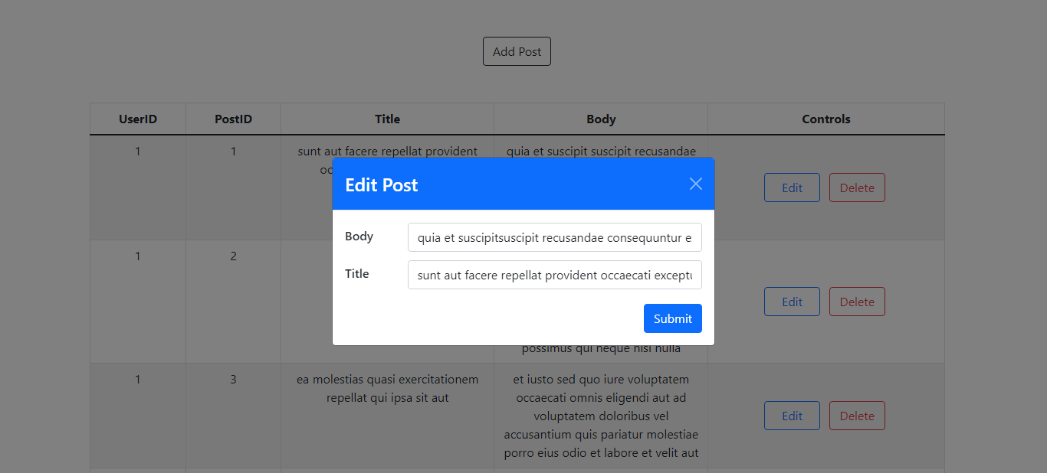
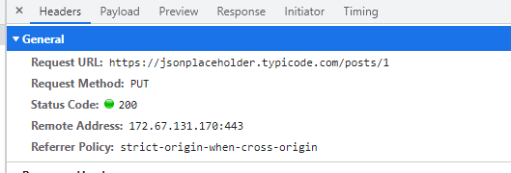

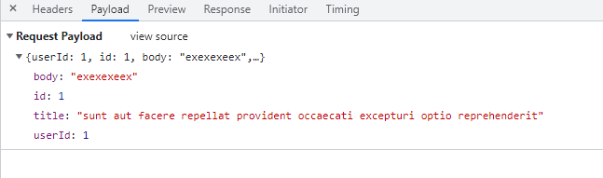

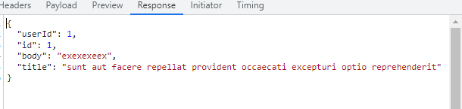

Delete Button
